OFFICIAL RULES FOR 2018 JPL INVENTION CHALLENGE

The JPL Annual Invention Challenge is celebrating its twentieth anniversary. The title for this year’s contest is the “Upright Pipe Contest”. The objective and rules are listed below. Questions related to this contest should be directed to: Paul MacNeal at work phone (818) 354-7824, M/S T1723-118, located in Building T1723-128, or e-mail to paul.d.macneal@jpl.nasa.gov.

OBJECTIVE: Create a device that can position a plastic pipe that is resting on two support stands into a vertical position atop a small platform in under sixty seconds. The winner will be the team whose device places the pipe in the upright position in the fastest time while complying with all rules.

Rules:

ELIGIBILITY
- The contest is open to all JPL employees, contractors, and immediate family members. The contest is also open to teams of students from Southern California middle schools and high schools if they have completed all required forms as outlined in rules 3 and 4 below.

REGISTRATION – JPL PERSONNEL
- Applications for JPL employees, contractors, and immediate family members entering the contest (found on website) must be filled out and submitted to Public Services prior to midnight November 10, 2018. Completed entry forms should be directed to Public Services at FAX (818) 393-4641, or sent via email to Kimberly.C.Johansen@jpl.nasa.gov. All entries will be time stamped based upon the time received. Only the first 20 JPL/contractor entries will be permitted to compete. Five alternates will be accepted in case some entries withdraw prior to the competition.

JPL employee family members and friends are welcome to watch the contest but must be cleared through the security office well in advance of the contest date. JPL employees must fill out the visitor request form as found in the link: https://id.jpl.nasa.gov/login

REGISTRATION – SCHOOLS
- To make it easier to process badging at JPL, each team must email their completed, typed entry form (found on website) to Kimberly.C.Johansen@jpl.nasa.gov. Additionally, to make the badging process flow smoothly each team must mail a printout of their completed student team entry form and the “Authorization and Release for Photos, Audio and/or Video Recordings of and/or Artwork” agreement form (found on website) for each person (student, guest, teacher, and chaperone) planning to attend the JPL contest. Each video release form must be completely filled out and signed. If the student is under 18 years of age, then use the appropriate form filled out and signed by their parent or guardian. The emailed entry form and entire set of video release forms must be filled out and submitted to Public Services no earlier than September 3, 2018 and be postmarked no later than midnight September 29, 2018. Completed forms must be mailed to Public Services at Jet Propulsion Laboratory, M/S 186-113, 4800 Oak Grove Drive, Pasadena, CA 91109. All entries will be time stamped based upon the time received. Student teams will be notified to verify their acceptance into the contest by October 3, 2018. Questions regarding the entry forms can be directed to Kimberly.C.Johansen@jpl.nasa.gov in Public Services at (818)393-4641. Each school is allowed no more than three teams. Internal school competitions are encouraged to select the top three teams if necessary.

IMPORTANT: Any foreign person, 18 or over, student or adult, will need to fill out a special form which is processed by the Public Services Office. The process takes nearly three weeks; therefore, if anyone (students, teachers, chaperones) plans to attend the contest at JPL, and they are a foreign national, it is important that they contact Paul MacNeal prior to November 5, 2018.

For those teams invited to the final contest held at JPL, additions or corrections to the registration forms and/or video release forms need to be mailed to the Public Services Office with a postmark no later than Friday, November 30, 2018. Faxed forms will not be accepted. Failure to send in the signed video release form by the requisite time will prevent participation and access to the JPL contest for those that fail to comply with this request.

SPECIAL RULES FOR SCHOOL TEAMS
4) Only the first 90 student team entries will be permitted to compete at the regional competitions. Student teams will compete at a regional competition held on Saturday, November 17, 2018 at either Augusta Hawkins High School in Los Angeles or the University of California at Irvine (UCI) in Irvine. Details for the regional competitions will be sent to all registered teams. The top five teams with the fastest times for completing the task from each regional competition will be invited to compete at the JPL contest held on Friday, December 14, 2018 (see Rule 5 below). In addition, the next 10 teams with the fastest times between both regional competitions will also be invited to compete at the JPL contest.

LOGISTICS
5) The date and time for the final contest is Friday, December 14, 2018 between 11:30 AM and 1:00 PM. The contest is held at the Jet Propulsion Laboratory, 4800 Oak Grove Drive, Pasadena, CA 91109. The contest area is located north of the fountain area, in front of the Administration Building (Bldg. 180) steps. In the event of heavy rain (more than mist) or extreme wind, the contest will be held indoors. Check-in for the event will begin at 10:15 AM.

DEVICE RULES
6) The device must have the following characteristics:
- Can maneuver an officially supplied plastic pipe (see Rule 6n) that rests on two officially supplied stands (see Rule 6o), raise the pipe into a vertical position, and have the pipe come to rest without falling on a small horizontal platform (see Rule 6p). The end of the pipe must lay flat with no part of the pipe hanging over the edge of the platform. The task must be completed within sixty seconds.
- Cannot damage the pipe in any way. No cracks or cuts can be caused by the device. Damaging the pipe may lead to disqualification.
- Cannot alter the pipe in any way. No adhesives or tapes are permitted to touch the pipe.
- Be initiated by a single operation (cut a string, flick a switch, pull a pin, drop a weight, etc.) provided by the contestant. No human power may be used during the initiation of the device to add dynamic or potential energy to produce motion of the device. All stored energy systems must be energized prior to the start of the task. No remote control devices of any kind are allowed.
- Cannot touch the pipe in any way prior to the start of the task.
- Cannot touch the support stands or the platform in any way before, during, or after the task.
- Cannot touch the pipe nor have any portion of the device reside inside the center of the pipe at the end of the task.
- At no time before, during, or after the task can the device expand beyond the dimensions of the set-up area (see Rule 7). There is no restriction on height. Violation of this rule will disqualify the device from the contest.

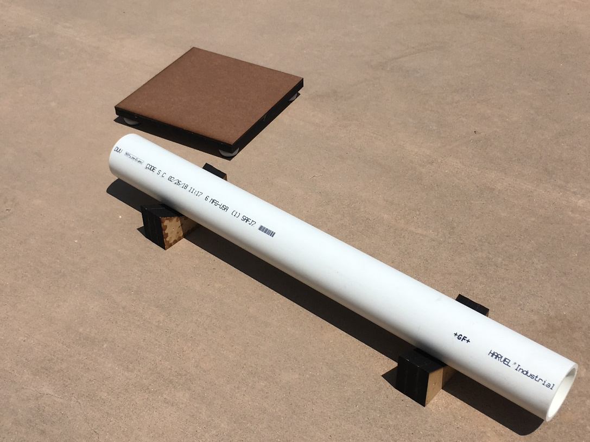

- Utilize safe energy sources. Examples of disallowed energy sources are chemical explosions, caustic gases, and rocket motors. High pressure gas systems and other questionable sources must be cleared through Paul MacNeal and the Safety Coordinator prior to performing at both the regional contest and the final contest. An electrical cord will be available for use.
- Be made from any materials if they are non-toxic and safe.
- Place the official entry number provided by the contest organizer (3” high numbers or larger) on at least two sides of the device for easy identification.
- Not use any clamps, tape, or any other means to attach to the ground. The device must only rest on the ground, however heavy weights may be used.
- Can adapt to non-level ground (see Rule 7).

- For practicing purposes, the 2” PVC Schedule 40 plastic pipe can be purchased at any hardware or plumbing store and then trimmed to the proper length. The overall length of the pipe is 60 cm +/- 1 mm [23.6” +/- 0.04”], has an outer diameter of 60.32 mm [2.375”], and an inner diameter of approximately 52.0 mm [2.05”]. The approximate weight of the pipe is 652 grams [1.44 lbs].
- The support stands are officially supplied by the host and are depicted below. They provide a 2.5 cm [≈1.0”] gap between the bottom edge of the pipe and the ground. The spacing between the support stands is determined by each team.

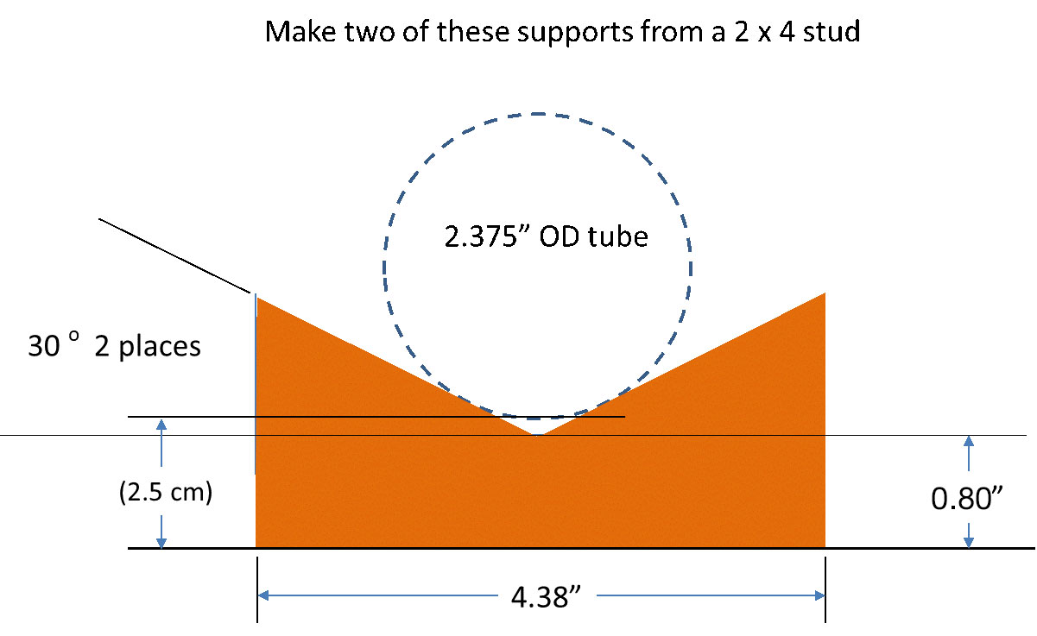

- The small platform is made from wood and has spacers in the four corners to ensure that the top surface is horizontal. The square platform is 20 cm [7.87”] on a side and the top surface is approximately 3 cm [1.2”] above the surface of the contest site (see Rule 7).
- SPECIAL RULE FOR SCHOOL TEAMS ONLY: To avoid plagiarism, each team that competes at the regional contest will have photographs taken of their device. The basic concept of the device (energy source type, maneuver method, and size) must be maintained. Minor modifications to the device are allowed within these constraints.

CONTEST AREA DESCRIPTION
- The contest site is in front of the steps leading to Building 180. The site will contain two areas for setting up and operating the device. The size of each set-up area is 2 meters by 2 meters. Each team will be randomly assigned to either set-up area. The ground is concrete with a rough finish and has a slight slope (approximately 1 degree across the width as shown in Figure 1). See Figure 1 for a description of the contest area.

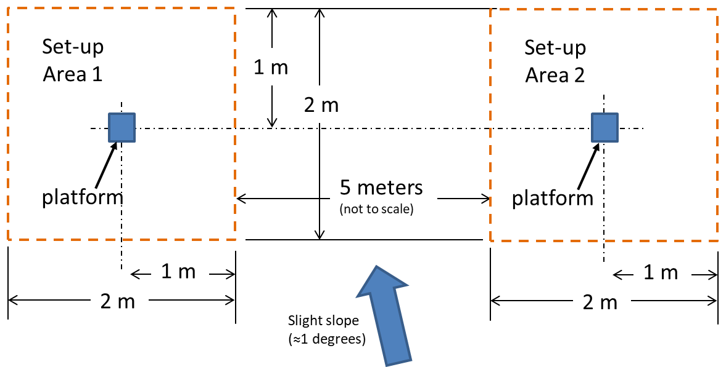

Figure 1. Contest Area – top view

CONTEST PROCEDURE
- The order in which teams will participate is selected by a random process. The team will be given a three-minute period to setup their device. Safety advisors will be observing the team during their setup time and will warn and potentially stop the team if any setup operations can lead to potential accidents. Strict time limits will be imposed to ensure that all contestants are able to operate their device. At the beginning of the setup period each team will be handed the pipe and the support stands. Each team will place the pipe resting on the two supplied support stands. The pipe can be placed anywhere within the set-up area, but it cannot touch the small horizontal platform.

Each team shall designate a speaker that is not involved with the device setup to talk about their team and their device during the setup period. The team will be asked if they are ready to proceed. The referee will ensure that the device is not touching the pipe prior to beginning the task. The procedure for running the task and determining the official time for the task is as follows:
- The referee will give a countdown (3...2...1...GO!) for the start of operation for the device.
- The timers will start the time at the referee’s direction.
- The referee will observe the task and make sure that the team does not provide any energy to assist the task. The referee will also observe that the device remains within the set-up area.
- The referee will yell an audible “STOP” when the pipe has come to rest in a vertical position on the platform without any visible oscillating (when oscillations are smaller than approximately 1.0 mm [0.04”] at the top of the pipe). The decision of the referee is final.
- The referee will verify that the device is not touching the pipe at all nor has any portion of the device residing inside the center of the pipe. Violation of this rule will disqualify the device from the contest.
- The timers will compare their times and the lead timer will write down the time it took to complete the task to the nearest 0.01 seconds on the scoresheet. Any official time that is greater than sixty seconds shall render the task a failure.
- All decisions of the referee are final.

All teams will be asked to remove their device and place it back in their original waiting area.

The winning team will be the team whose device completed the task without any violations of the rules in the fastest time. Times within 0.05 seconds will be counted as a tie. If two or more teams are tied, each team will be asked to repeat the entire task and the same rules for declaring the winner will apply.

AWARDS
- Trophies will be divided into two categories: JPL employees/family/contractor entries and school team entries. Trophies will be given for first, second, and third place for each category at all contests (regional contests and the JPL contest). Certificates will be issued for the lightest, heaviest, most unusual, most artistic, and most creative designs.

